**Chhattisgarh**

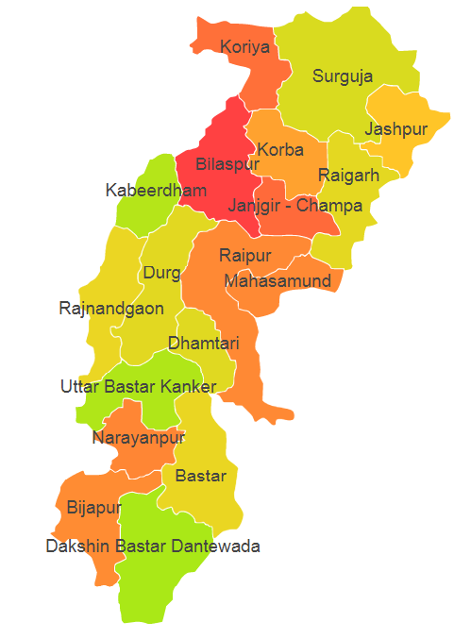

Chhattisgarh comprises of Agro Ecological Region (AER) 11.

**Agro-Eco Region 11:** AER 11 in Chhattisgarh comprises of Bastar, Bijapur, Bilaspur, Dabtewara, Dhamtari, Durg, Janjgir Champa, Jashpur, Kanker, Kawardha, Korba, Korea, Mahasamund, Narayanpur, Raigarh, Raipur, Rajnandgaon and Surguja districts of Eastern Plateau under Agro Ecological Sub Region (AESR) 11.